  University of Buea | Faculty Of Engineering & Technology
Computer Department | Software Engineering

CEF440 – Internet and Mobile Programming (Task 6)
Group List
Name | Matricule
Mugha Brayan Aya-ah Ndefru | FE23A097
Ako McPeace Njoh | FE23A009
EYONG AKAGO ANELKA NELVINE | FE23A056
NGOLIEN LUCY ETHEL LIBOG | FE22A261

Github Repository: https://github.com/BrayanMorningstar237/CEF440_Group5
Project: Design and Implementation of a Mobile App for Collection of User Experience Data from Mobile Network Subscribers

Task 6: Database Design and Implementation
Introduction
The project requires a database system capable of collecting, storing, managing, and analyzing Quality of Service (QoS) and Quality of Experience (QoE) data submitted by mobile network subscribers. The database architecture was designed to support offline data collection on mobile devices, secure synchronization with a centralized server, user management, and administrative reporting. The implementation utilizes SQLite for local storage on the mobile application and MongoDB for centralized backend storage.
Data Elements
The system stores information related to users, network cells, and QoS/QoE measurements. The major data elements used in the application are presented below.
User Entity
Attribute | Data Type | Description
_id | ObjectId | Unique user identifier
name | String | Subscriber or administrator name
email | String | Unique email address
passwordHash | String | Encrypted password
role | String | User role (Admin or Subscriber)
createdAt | DateTime | Account creation date
updatedAt | DateTime | Last modification date
Network Cell Entity
Attribute | Data Type | Description
cellId | String | Unique network cell identifier
ispProvider | String | Mobile network provider
country | String | Country name
region | String | Administrative region
city | String | City name
Measurement Entity
Attribute | Data Type | Description
_id | ObjectId | Unique measurement identifier
userId | ObjectId | Reference to subscriber
cellId | String | Reference to network cell
localId | Number | Local measurement identifier
createdAt | DateTime | Measurement timestamp
networkType | String | Mobile or Wi-Fi
networkGeneration | String | 2G, 3G, 4G, 5G, Wi-Fi
latencyMs | Number | Measured latency
jitterMs | Number | Measured jitter
packetLossPercent | Number | Packet loss percentage
uploadMbps | Number | Upload speed
downloadMbps | Number | Download speed
signalStrengthDbm | Number | Signal strength
coordinates | GeoJSON | GPS coordinates
accuracyM | Number | GPS accuracy
stabilityRating | Number | Stability score
browsingRating | Number | Browsing experience score
streamingRating | Number | Streaming experience score
comment | String | User feedback
source | String | Data source
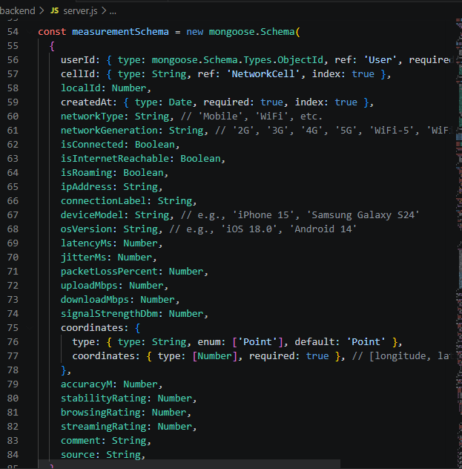 Conceptual Design
The conceptual database design follows a normalized structure consisting of three primary entities: User, Network Cell, and Measurement. The design aims to eliminate redundancy while ensuring efficient storage and retrieval of network performance data.
Subscribers use the mobile application to collect QoS and QoE measurements. Each measurement is associated with a specific subscriber and network cell. Administrators are granted access to all collected measurements for monitoring, reporting, and analysis purposes.
The architecture follows a hybrid storage model. Measurements are initially stored locally using SQLite when the device is offline. Once connectivity becomes available, the data is synchronized with the centralized MongoDB database through RESTful APIs. This design guarantees uninterrupted data collection and reliable data transmission.
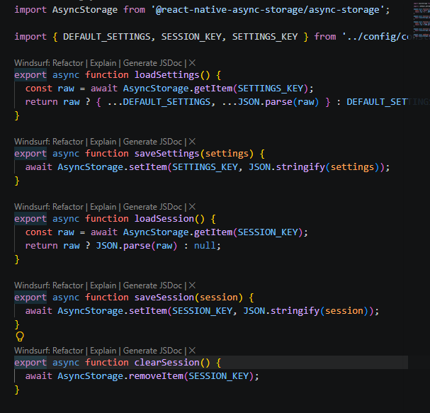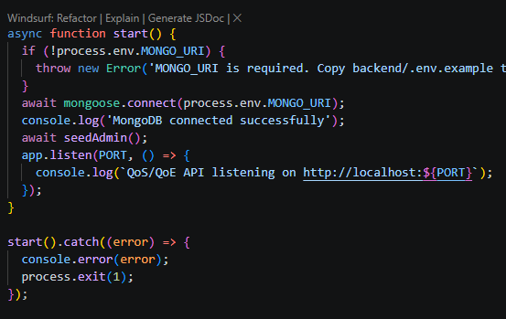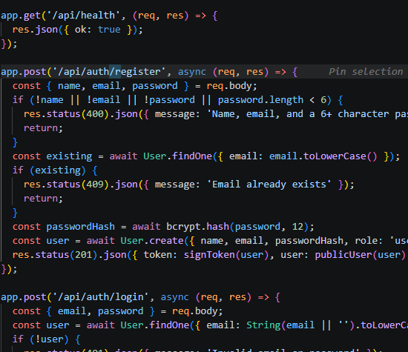

ER Diagram
The Entity Relationship Diagram illustrates the relationships between User, Network Cell, and Measurement entities.
A User records multiple Measurements, creating a one-to-many relationship. A Network Cell hosts multiple Measurements, also resulting in a one-to-many relationship. The Measurement entity serves as the central entity linking subscribers and network infrastructure data.
Relationship | Cardinality
User records Measurement | One-to-Many (1:N)
Network Cell hosts Measurement | One-to-Many (1:N)
Administrators and Subscribers are represented within the User entity through the role attribute rather than separate tables. This design simplifies user management while supporting role-based access control.
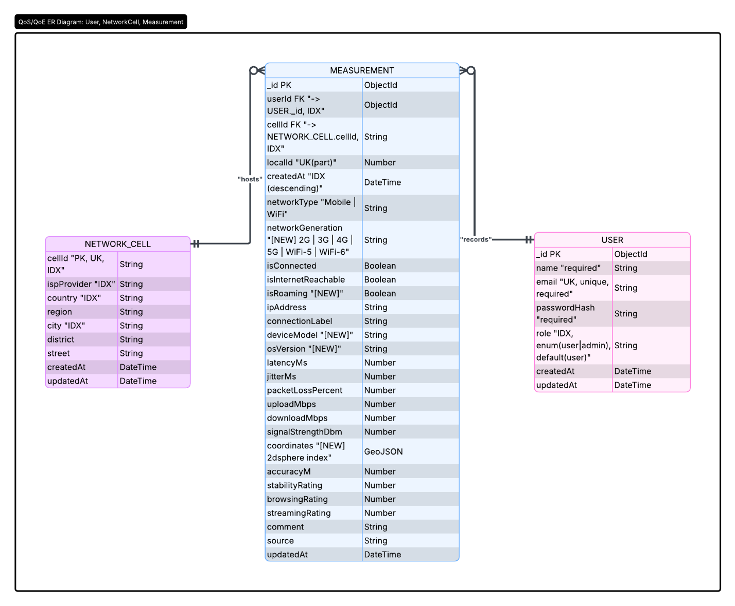
Database Implementation
The centralized database was implemented using MongoDB and Mongoose. MongoDB was selected because of its scalability, flexibility, and ability to efficiently handle large volumes of measurement data.
The User collection stores subscriber and administrator information. Unique constraints are enforced on email addresses to prevent duplicate registrations.
The Network Cell collection stores network infrastructure information. By separating network location information into its own collection, redundant storage of identical cell information across thousands of measurements is avoided.
The Measurement collection stores QoS and QoE metrics collected by subscribers. Foreign key references link each measurement to both a user and a network cell. Several indexes were implemented to improve query performance.
Indexed Field | Purpose
userId | Fast retrieval of subscriber measurements
cellId | Efficient cell-based analysis
createdAt | Time-based queries
ispProvider | Provider-specific filtering
coordinates | Geospatial analysis
The coordinates field utilizes a 2dsphere geospatial index, allowing future implementation of location-based queries and network performance mapping.
The mobile application implements a local SQLite database to temporarily store measurements before synchronization. Functions such as saveMeasurement(), loadMeasurements(), and markUploaded() are used to manage local records.
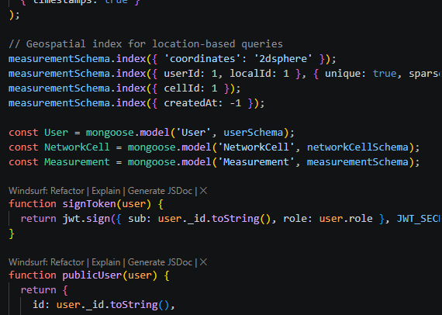 Backend Implementation
The backend server was developed using Node.js and Express.js. Mongoose is used for database interaction, JWT for authentication, bcryptjs for password encryption, dotenv for environment variable management, and CORS for cross-origin communication.
The authentication module provides subscriber registration, login, profile management, and token generation. Passwords are securely hashed before storage.
The measurement module provides endpoints for uploading measurements, retrieving subscriber data, and accessing administrative reports.
Endpoint | Method | Purpose
/api/auth/register | POST | Register subscriber
/api/auth/login | POST | Authenticate user
/api/me | GET | Retrieve profile
/api/measurements/bulk | POST | Upload measurements
/api/measurements/mine | GET | Retrieve subscriber measurements
/api/admin/measurements | GET | Retrieve all measurements
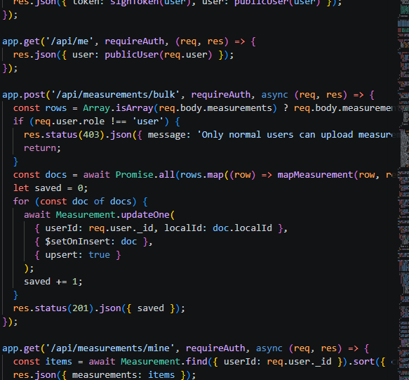
Administrators can filter data by provider, location, network type, and quality indicators to generate analytical reports.
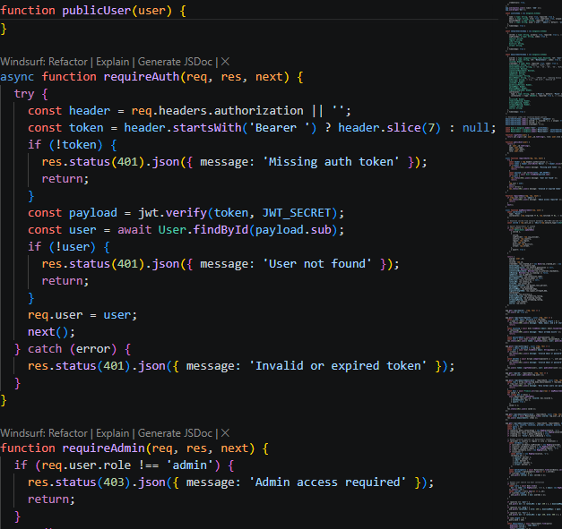 Connecting Database to Backend
The backend establishes a secure connection to MongoDB using Mongoose. Database connection details are stored within environment variables to enhance security and maintainability.
When a subscriber performs a network measurement, the data is first stored locally in SQLite. The application continuously checks for network availability and synchronizes pending records with the backend API. Once synchronization is successful, the records are marked as uploaded to prevent duplicate submissions.
The synchronization workflow follows these steps:
Step | Process
1 | Subscriber records QoS/QoE measurement
2 | Measurement stored in SQLite
3 | Application loads unsynchronized records
4 | Records uploaded through REST API
5 | Backend validates and stores data in MongoDB
6 | Local records marked as synchronized
This approach ensures reliability, fault tolerance, and continuous data collection even in areas with poor connectivity.
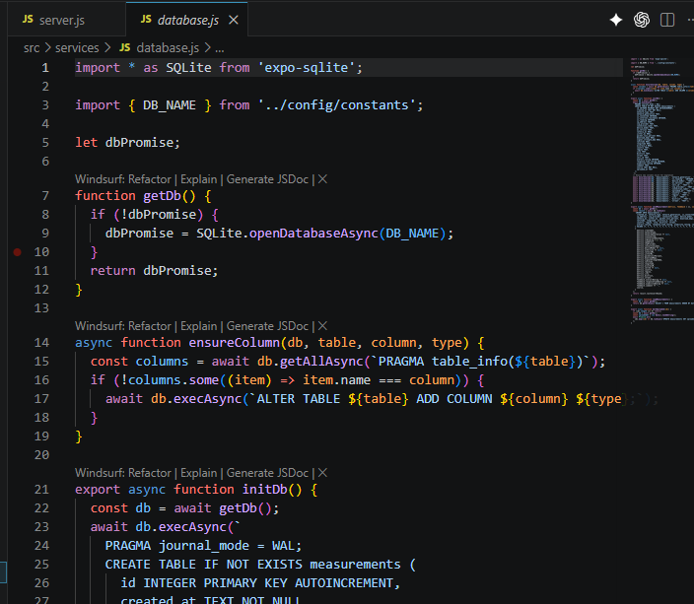 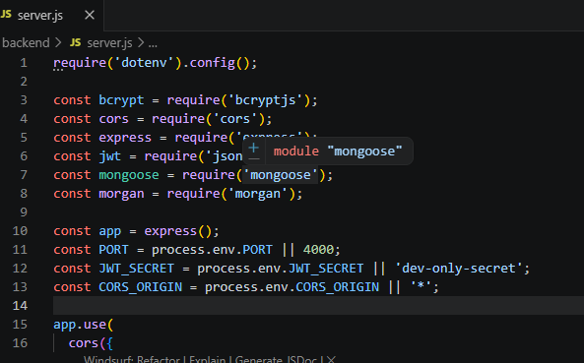 Conclusion
The database design and implementation successfully support the objectives of the mobile application for collecting user experience data from mobile network subscribers. The hybrid architecture combining SQLite and MongoDB provides both offline functionality and centralized storage. The normalized database structure minimizes redundancy, improves scalability, and enhances data integrity. Through the integration of user management, network cell management, QoS/QoE measurement storage, and secure synchronization mechanisms, the implemented database system effectively meets the functional requirements of the project.

